**TASK 1**

Here are some online activities in order to learn and / or practise the verb “TO BE” and “TO HAVE”.

**The Verb TO BE – Simple Present**

* **Easy English (2015, Diciembre 5). The verb "TO BE" - Simple Present - Easy English Class [Archivo de video] Recuperado de:** <https://www.youtube.com/watch?v=co6lmoOoZsU&t=4s>

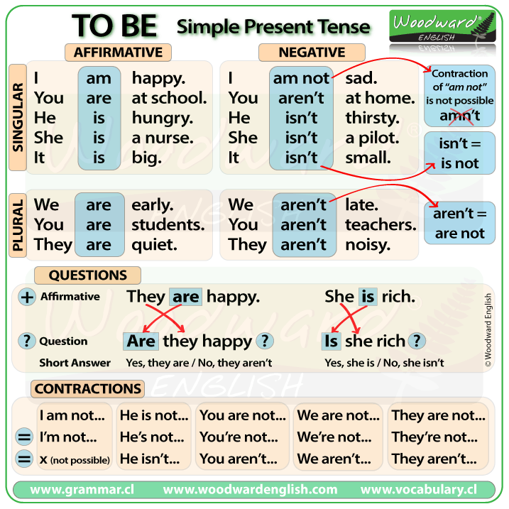

**TO BE – Simple Present Tense**

* Recuperado de: <https://www.pinterest.de/pin/568860996675513328/>

**Superprof – Material Didáctico – Verb Tense**

**Recuperado de:** <https://www.superprof.es/apuntes/idiomas/ingles/gramatica-inglesa/verb-tense/>

**TO BE – Practice**

* **Affirmative Form**

<https://www.superprof.es/apuntes/idiomas/ingles/gramatica-inglesa/verbs/exercises-to-be-simple-present.html>

* **Negative Form**

<https://www.superprof.es/apuntes/idiomas/ingles/gramatica-inglesa/verbs/exercises-to-be-simple-present-negative.html>

* **Interrogative Form**

<https://www.superprof.es/apuntes/idiomas/ingles/gramatica-inglesa/verbs/exercises-to-be-simple-present-interrogative.html>

**The Verb TO HAVE – Present Simple**

# Easy English (2015, Diciembre 5) The verb "TO HAVE" - Simple Present - Easy English Class [Archivo de video] Recuperado de: <https://www.youtube.com/watch?v=7Mi8KHU91EI>

# Verb 'To have': simple present affirmative

<https://www.superprof.es/apuntes/idiomas/ingles/gramatica-inglesa/verbs/verb-to-have-simple-present-affirmative.html>

**TO HAVE – Practice**

* **Affirmative Form**

<https://www.superprof.es/apuntes/idiomas/ingles/gramatica-inglesa/verbs/exercises-to-have-simple-present-affimative.html>

* **Negative Form**

<https://www.superprof.es/apuntes/idiomas/ingles/gramatica-inglesa/verbs/exercises-to-have-simple-present-negative.html>

* **Interrogative Form**

<https://www.superprof.es/apuntes/idiomas/ingles/gramatica-inglesa/verbs/exercises-to-have-simple-present-interrogative.html>

**The Indefinite Article**

* Exercise 1: <https://www.curso-ingles.com/practicar/ejercicios/the-indefinite-article>
* Exercise 2: <https://www.curso-ingles.com/practicar/ejercicios/the-indefinite-article-2>

**Unit Test:**  <https://www.curso-ingles.com/practicar/ejercicios/the-indefinite-article-2>